Validation on Email ID

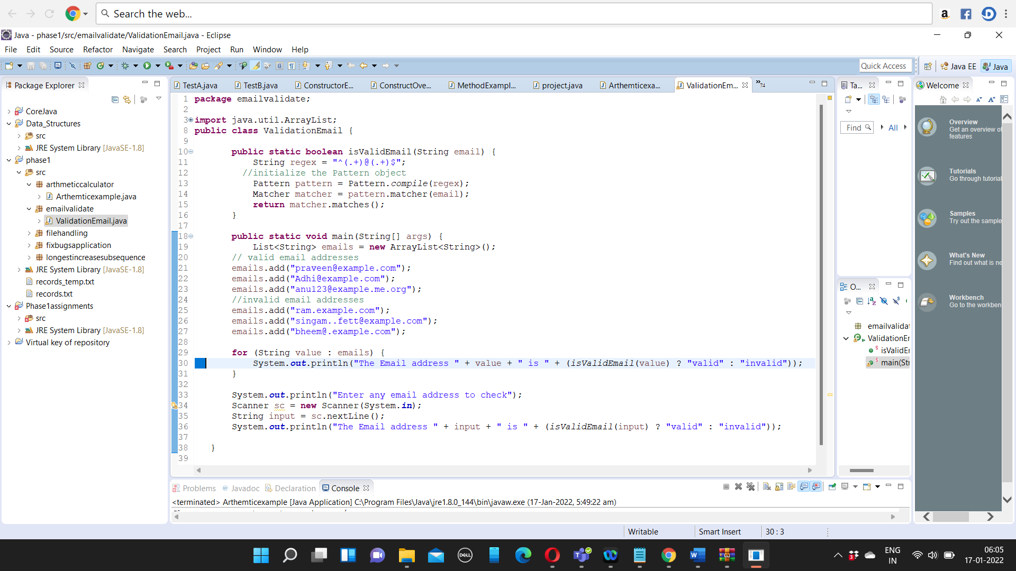

OUTPUT

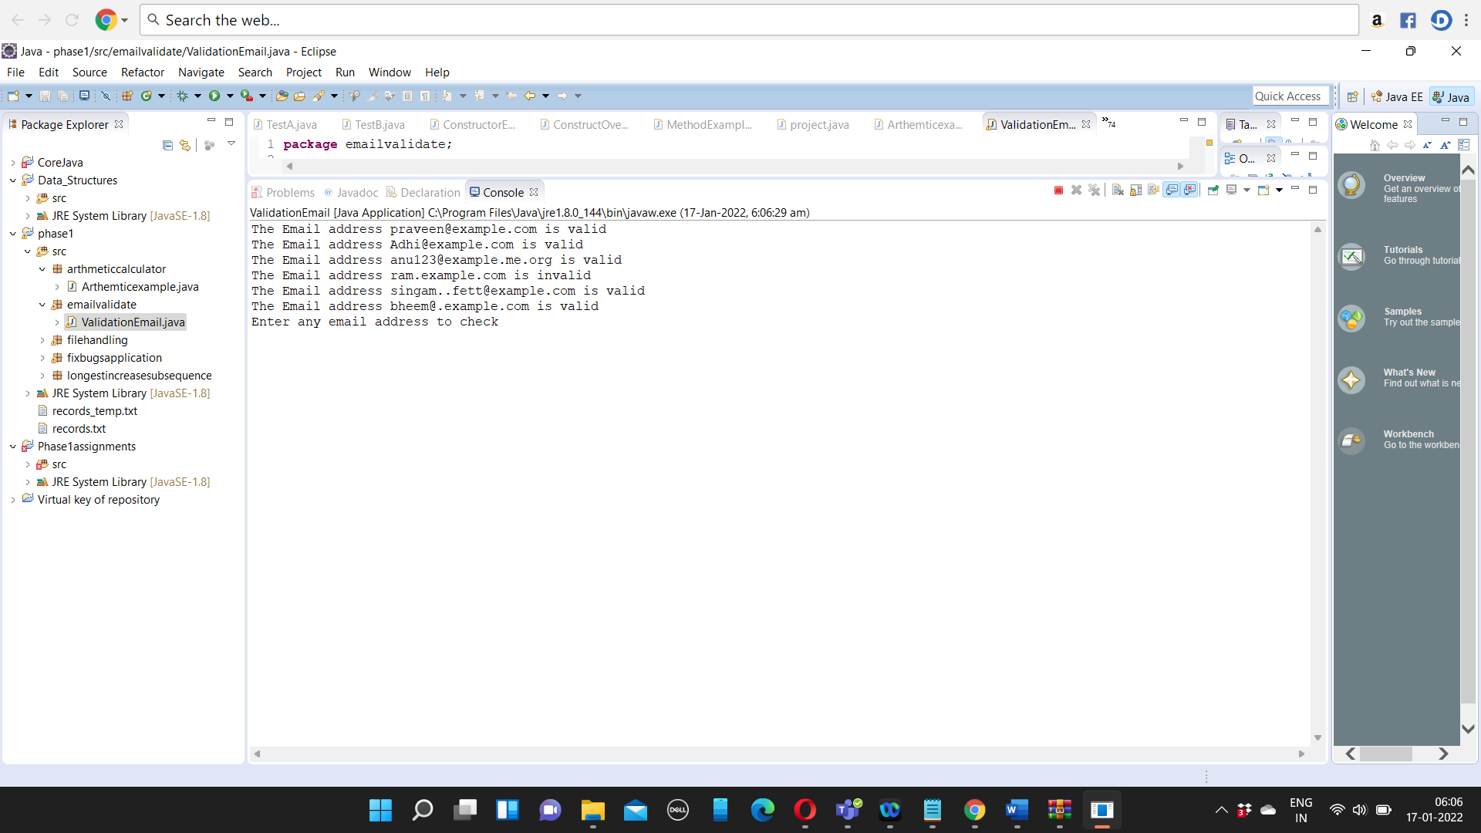

Program:

package emailvalidate;

import java.util.ArrayList;

import java.util.List;

import java.util.Scanner;

import java.util.regex.Matcher;

import java.util.regex.Pattern;

public class ValidationEmail {

public static boolean isValidEmail(String email) {

String regex = "^(.+)@(.+)$";

//initialize the Pattern object

Pattern pattern = Pattern.compile(regex);

Matcher matcher = pattern.matcher(email);

return matcher.matches();

}

public static void main(String[] args) {

List<String> emails = new ArrayList<String>();

// valid email addresses

emails.add("praveen@example.com");

emails.add("Adhi@example.com");

emails.add("anu123@example.me.org");

//invalid email addresses

emails.add("ram.example.com");

emails.add("singam..fett@example.com");

emails.add("bheem@.example.com");

for (String value : emails) {

System.out.println("The Email address " + value + " is " + (isValidEmail(value) ? "valid" : "invalid"));

}

System.out.println("Enter any email address to check");

Scanner sc = new Scanner(System.in);

String input = sc.nextLine();

System.out.println("The Email address " + input + " is " + (isValidEmail(input) ? "valid" : "invalid"));

}

}